Day 16

From the end of last Wednesday:

What is matter?

* Anything that has mass and takes up space

How many different kinds of matter are there?

- Infinite

How can we keep track of all of this?

-Use elements!

Elements are the building blocks of matter.

What is the smallest piece of an element?

**What is an atom?**

**What is the difference between an element and an atom?**

**What is a molecule?**

An **atom** is the smallest unit of an element that retains the properties of that element. A **molecule** is formed when two or more atoms are hooked together, stay together, and act like one unit. A molecule is the smallest unit of a substance that retains the properties of that substance.

**What is the difference between physical and chemical changes?**

Any change that produces a new substance is called a **chemical change**. Changes that don't produce new substances are **physical changes**.

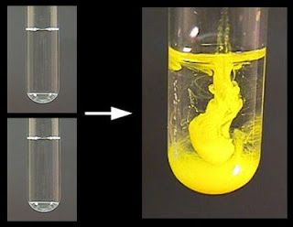

**What happens in a chemical reaction?**

Chemistry is about taking substances (that are made of elements or combinations of elements) and combining them with other substances to create new substances that have different properties from any of those that you start with. It is a matter of rearranging the elements into different combinations to make new materials. This is the underlying concept that defines what chemistry is about.

What do you know about the periodic table?

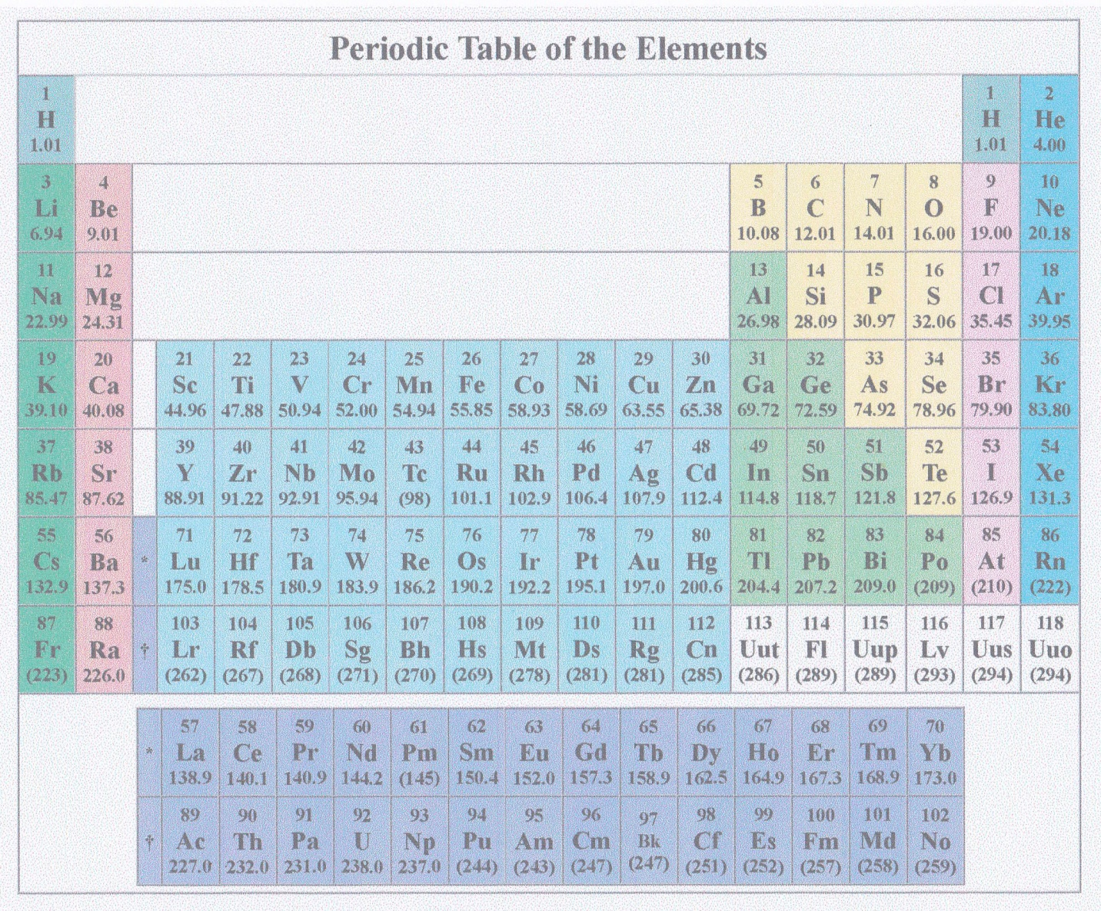

What makes the periodic table periodic?

Conductivity of water –

* What do you need to turn a light on?

Three things –

Conductivity video –

Polls –

* Do metals conduct?
* Will plain water conduct?
* Will sugar water conduct?
* Will salt water conduct?

To illustrate that elements in the same column have similar properties, look at Li, Na, and K. They are all in the first column.

How does reactivity change as you go down the periodic table?

In this [video](https://www.youtube.com/watch?v=O9PhHvEjKhM) the lithium, Li, is on the right, the sodium, Na, is on top, and the potassium, K, is on the left.

Li, Na and K in water video - -

Which is most reactive? This illustrates a general rule about reactivity and the periodic table. How would you state the rule?

The lower an element is on the periodic table, the more reactive it is.

Day 17

Model of an atom –

How would you draw a picture of an atom?