 | 

Classification
Administration Procedures
Contributed by: Illinois Science Teachers Association

Description:
Students use a binary classification system to divide objects, then justify their scheme.
The task assesses primary students' abilities to perform process skills such as classification by using observable differences and similarities.
This task is designed to take students approximately 8 minutes to complete.

Overall Task Content Area:
Physical Science

Specific Knowledge Areas:
Properties of Objects and Materials

Performance Expectations:
- conducting investigations
- applying scientific principles to develop explanations and solve new problems

National Science Education Standards:
4 A SI 1: Abilities necessary to do scientific inquiry: Grades K-4
1.5 Communicate investigations and explanations. Students should begin developing the abilities to communicate, critique, and analyze their work and the work of other students. This communication might be spoken or drawn as well as written.
4 B PS 1: Properties of Objects and Materials: Grades K-4
1.1 Objects have many observable properties, including size, weight, shape, color, temperature, and the ability to react with other substances. Those properties can be measured using tools, such as rulers, balances and thermometers.
(Use the "hot" link on the PALS home page to check the full text of related National Science Education Standards, if desired.)

National Council of Teachers of Mathematics:
AL1: Understand patterns, relations and functions:
Grades pre K-5 a. sort, classify, and order objects by size, number, and other properties.
DAP1: Formulate questions that can be addressed with data and collect, organize, and display relevant data to answer them:
Grades pre K-5 b. sort and classify objects according to their attributes and organize data about the objects
GEO1: Analyze characteristics and properties of two- and three-dimensional shapes and develop mathematical arguments about geometric relationships:
Grades pre K-5 b. describe attributes and parts of two- and three-dimensional shapes
MEAS1: Understand measurable attributes of objects and the units, systems, and processes of measurement:
Grades pre K-5 b. compare and order objects according to these (length, volume, weight, area, and time) attributes
PS3: Apply and adapt a variety of appropriate strategies to solve problems:
Grades pre K-5
RP2: Make and investigate mathematical conjectures:
Grades pre K-5
REP1: Create and use representations to organize, record, and communicate mathematical ideas:
Grades pre K-5

General Instructions to the Teacher:
This task is designed to take students approximately 8 minutes to complete.
Students will be working individually during this exercise.
Students should be ready to work as soon as the period begins. The materials should be set out at each lab station, if possible. A central supply area, if needed, should be easily accessible. All supplies should be clearly labeled.

Materials for "Classification":
The teacher will need:
- colored paper
- scissors
- plastic bags
At this station students should have:
- large blue square 2.5"
- small blue square 1.5"
- large blue triangle (cut large blue square in half diagonally)
- small blue triangle (cut small blue square in half diagonally)
- large yellow square 2.5"
- small yellow square 1.5"
- large yellow triangle (cut large yellow square in half diagonally)
- small yellow traingle (cut small yellow square in half diagonally)

Advance Preparation:
- Cut out paper squares and triangles.
- Put shapes into bag.

Safety:
- Be careful.
- Teachers and students should always exercise appropriate safety precautions and utilize appropriate laboratory safety procedures and equipment when working on science performance tasks.

Extensions/modifications:
- Classification is one part of a five part assessment that was administered in Illinois. The other 4 stations are "Measurement: Length, volume, and temperature," "Measurement: Using the balance," "Mystery Boxes," and "Magnetic Testing."
- Rubric language should be targeted to the specific NCTM standard(s) to be measured.

Advanced Preparation Set Up:
Measure small and large squares.  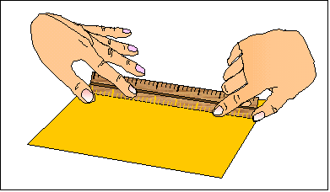 | Cut shapes.  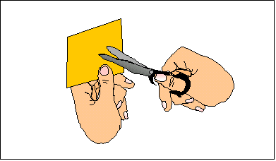
Put shapes in bags.
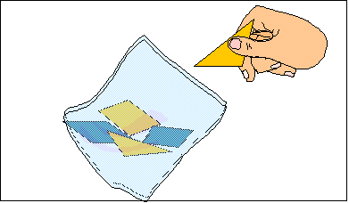

©1997-2005 SRI International, Center for Technology in Learning. All rights reserved. Terms of Use

