 | 

Classifying Candy 2
Task with Student Directions
4th Grade Performance Task
Contributed by: New York State Education Department (NYSED)
NYS Alternative Assessment in Science Project (1996)

Task:
At this station you will be putting candy into groups.

Materials:
- candy bag
- test card

Directions:

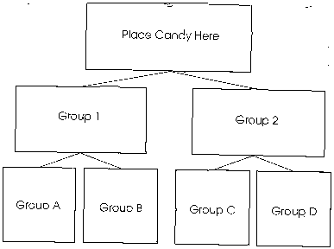
A. Place all of the candy on the test card in the box labeled Place Candy Here.
B. Using the test card as your guide, divide all the candies into two (2) groups, group 1 and group 2.
C. All of the candies in group 1 must have the same property and all of the candies in group 2 must have the same property.
D. Use all the candy.

Questions:
1. What property does the candy in group 1 have?

2. What property does the candy in group 2 have?

Directions:
E. Next, using the test card as your guide, divide group 1 into two (2) groups, A and B, so that all of the candy in each of the new groups has the same property.
F. Use all of the candy in group 1.

Questions:
3. What property does the candy in group A have?

4. What property does all the candy in group B have?

Directions:
G. Next, go back to group 2. Using the test card as your guide, divide group 2 into two (2) groups, C and D, so that all of the candy in each of the new groups has the same property.
H. Use all of the candy in group 2.

Questions:
5. What property does the candy in group C have?

6. What property does the candy in group D have?

©1997-2005 SRI International, Center for Technology in Learning. All rights reserved. Terms of Use

