 | 

Classifying Rocks
Task with Student Directions
Contributed by: Kentucky Department of Education (KDE)
PERFORMANCE TASK STUDENT DIRECTIONS/RESPONSE SHEET
TASK: S2 - CLASSIFYING ROCKS
Grade 4
STUDENT NAME: _______________________________________________
SCHOOL NAME: _______________________________________________

GENERAL INSTRUCTIONS:
At your station you have a collection of rocks that have many differences. Some are smooth, some are very grainy, some are colored. These differences are called properties. Some properties are very easy to see, or feel. Other properties are hard to discover and you may need to use the magnifying lenses to look closely to discover the similarities and differences in the rock samples.
Think about a property of the rocks. Then think about the opposite conditions of that property. The first property you will use is size. The opposite conditions of that property are "large" and "small." Sort your rocks by putting large ones in one pile, and small ones in another pile. The differences do not need to be very great, but you and your partners have to decide. When you have grouped them, count the number in each group and enter the number on your Data Sheet.
Your job now is to find other properties of the rock samples that have opposite conditions which you can use to divide, or classify, the rocks into two groups. To do this, follow these steps.
- Look at the rocks and decide on a property that has opposite conditions you can use to form groups. Write the name of the property in the chart on your Data Sheets.
- Name the opposite conditions of that property, and write them on your Data Sheets.
- Put the rocks in piles using those conditions. If some rocks do not fit in either group, put them in a third pile.
- Fill in the data sheet as you did in the first row.
Repeat this process for as many properties as you can, always entering the results on your Data Sheet.
INDIVIDUAL WORK
When you have done as much as you can, tell the person in charge or your teacher you are ready to begin to do your individual reports. Do not complete the Response Form as a group.

TASK: S2 - CLASSIFYING ROCKS
GRADE 4
STUDENT NAME: ___________________________________________________
SCHOOL NAME: ___________________________________________________
DATA SHEET
Use this sheet to show the ways you found to group the rocks into two groups. DO NOT write down the number of rocks that you put in the third pile of rocks that did not fit either group. Each time you see a new property to group the rocks, tell what property you used, and what you called the opposite conditions of that property. Show the number of rocks you put in each group (Group A and Group B). Do as many groupings as you can.
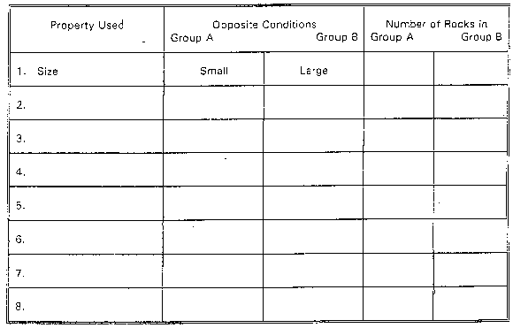
Classifying things by comparing properties is a very important part of what scientists do. You have just finished classifying rock samples. Use that experience to help you answer questions 1 and 2.
- Look at the four objects pictured below.
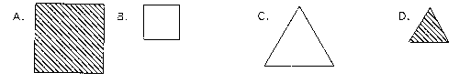
Find three properties of the objects, and the opposite conditions for those properties so that you can group the objects in three different ways. Fill out the chart below to show how you did the grouping.
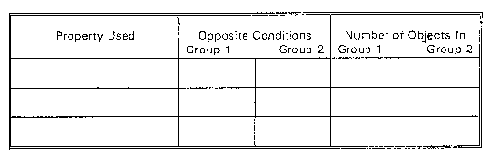
- Think about how you could classify groceries in a grocery store. In the space below, make a table that gives some properties with opposite conditions that could be used to classify groceries in a store. (Example: For the property "packaging," opposite conditions could be "hard containers" and "soft containers.")

Kentucky Department of Education
Performance Events 1992-93

©1997-2005 SRI International, Center for Technology in Learning. All rights reserved. Terms of Use

