 | 

Tree Study
Task with Student Directions
Contributed by: New Standards (NS)

The questions below are all about trees and leaves. Read each question carefully and write as complete an answer as you can.
Leaves from a tree have different sizes. Before you can decide about the usual size of leaves, you need to measure several of them.
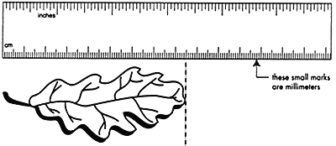

- Measure the length of these four leaves to the nearest millimeter (mm). Carefully organize and record your measurements below.
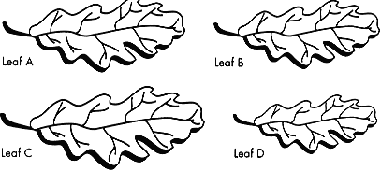

- If you were given another leaf from the same tree, how long do you think it would be? Explain why you chose this length.

- How correct do you think your measurements are? What two things could make your measurements wrong?

- A group of 4th graders was trying to learn more about the characteristics of the trees around their school. What would be a good question for them to investigate?

©1997-2005 SRI International, Center for Technology in Learning. All rights reserved. Terms of Use

