Pulse
Administration Procedures
4th Grade Performance Task
Contributed by: Third International Math and Science Study (TIMSS)
1993 Administration

Description:
Students determine a baseline pulse rate then chart the changes in rate with exercise. They then describe the changes and develop a rationale for their observations. The task assesses students' abilities to make simple observations, determine pulse rates, and make generalized inferences from their observations.
This task is designed to take students approximately 10-15 minutes to complete.

Overall Task Content Area:
Life Science

Specific Knowledge Areas:

Performance Expectations:
- conducting investigations
- using equipment
- gathering, organizing, and representing data
- applying scientific principles to develop explanations and solve new problems

National Science Education Standards:
4 A SI 1: Abilities necessary to do scientific inquiry: Grades K-4
1.4 Use data to construct a reasonable explanation. This aspect of the standard emphasizes the students’ thinking as they use data to formulate explanations. Even at the earliest grade levels, students should learn what constitutes evidence and judge the merits or strength of the data and information that will be used to make explanations. After students propose an explanation, they will appeal to the knowledge and evidence they obtained to support their explanations. Students should check their explanations against scientific knowledge, experiences, and observations of others.
4 C LS 1: The characteristics of organisms: Grades K-4
1.2 Each plant or animal has different structures that serve different functions in growth, survival, and reproduction. For example, humans have distinct body structures for walking, holding, seeing, and talking.
(Use the "hot" link on the PALS home page to check the full text of related National Science Education Standards, if desired.)

National Council of Teachers of Mathematics:
AL4: Analyze change in various contexts:
Grades pre K-5 a. describe qualitative change, such as a student's growing taller
DAP1: Formulate questions that can be addressed with data and collect, organize, and display relevant data to answer them:
Grades pre K-5 e. collect data using observations, surveys, and experiments
Grades pre K-5 f. represent data using tables and graphs such as line plots, bar graphs, and line graphs
MEAS2: Apply appropriate techniques, tools, and formulas to determine measurements:
Grades pre K-5 c. use tools to measure
COM1: Organize and consolidate their mathematical thinking through communication:
Grades pre K-5
CON3: Recognize and apply mathematics in contexts outside of mathematics:
Grades pre K-5
REP3: Use representations to model and interpret physical, social, and mathematical phenomena:
Grades pre K-5

General Instructions to the Teacher:
This task is designed to take students approximately 10-15 minutes to complete.
Students will be working individually during this exercise.
Students should be ready to work as soon as the period begins. The materials should be set out at each lab station, if possible.

Materials:
At this station students should have:
- A watch with a second hand
- A step on the floor to climb on

Advance Preparation:
- None required.

Extensions/Modifications:
- To expand and target the specific NCTM standard(s) to be measured,.ask the students to represent data using graphs.
- Rubric language should be expanded and targeted to the specific NCTM standard(s) to be measured.

Safety:
- Be careful.
- Teachers and students should always exercise appropriate safety precautions and utilize appropriate laboratory safety procedures and equipment when working on science performance tasks.

Advanced Preparation Set Up:
Make sure that students can take a pulse. The carotid pulse is found just in front of the muscle mass on the side of the neck and below the angle of the jaw. Always use the first two fingers when taking a pulse(not the thumb).  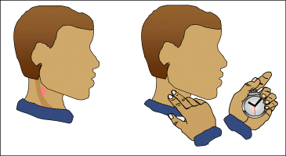 | The radial pulse is found on the wrist below the thumb to the outside of the tendons there.  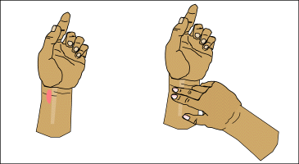
Make sure step is safe.
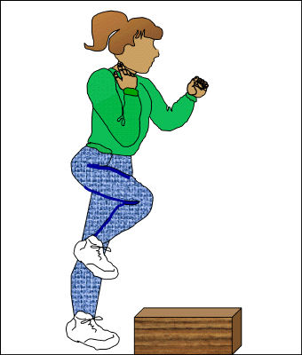

©1997-2005 SRI International, Center for Technology in Learning. All rights reserved. Terms of Use

