 | 

Electrical Circuits and Switches
Examples of Student Work
Contributed by: Council of Chief State School Officers (CCSSO)

Event Score = 2
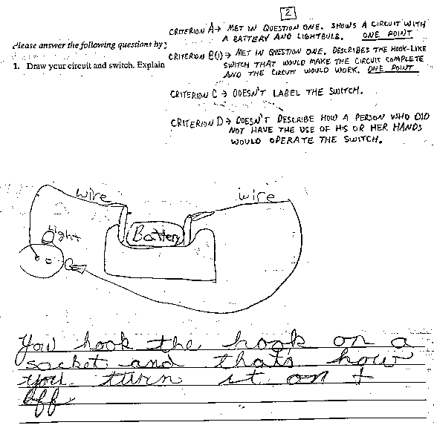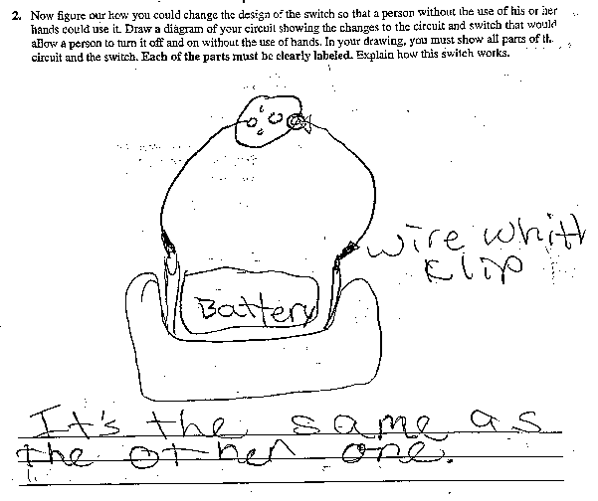

Previous Student Work | Next Student Work

©1997-2005 SRI International, Center for Technology in Learning. All rights reserved. Terms of Use

