 | 

Floating Pencil
Administration Procedures
Contributed by: National Assessment of Educational Progress (NAEP)

Description:
Students observe, measure, and compare the lengths of the portion of a pencil that floats above the water surface in fresh water and salt water. They then determine if an unknown water sample is fresh water or salt water, and predict how the addition of more salt to the salt water would affect the floating pencil.
The task assesses students' abilities to make simple observations, measure volume using a graduated cylinder, measure length using a ruler, apply their observations and measurements to test an unknown, make generalized inferences from their observations, and apply their understanding to an everyday situation.
This task is designed to take students approximately 20 minutes to complete.

Overall Task Content Area:
Physical Science

Specific Knowledge Areas:
Matter and its transformations

Performance Expectations:
- conducting investigations
- using equipment
- gathering, organizing, and representing data
- formulating conclusions from investigational data
- applying scientific principles to develop explanations and solve new problems

National Science Education Standards:
4 B PS 1: Properties of objects and materials: Grades K-4
1.1 Objects have many observable properties, including size, weight, shape, color, temperature, and the ability to react with other substances. Those properties can be measured using tools, such as rulers, balances and thermometers.
4 A SI 1: Ability to do scientific inquiry: Grades K-4
1.3 Employ simple equipment and tools to gather data and extend the senses. In early years, students develop simple skills, such as how to observe, measure, cut, connect, switch, turn on and off, pour, hold, tie, and hook. Beginning with simple instruments, students can use rulers to measure the length, height, and depth of objects and materials; thermometers to measure temperature; watches to measure time; beam balances and spring scales to measure weight and force; magnifiers to observe objects and organisms; and microscopes to observe the finer details of plants, animals, rocks, and other materials. Children also develop skills in the use of computers and calculators for conducting investigations.
1.4 Use data to construct a reasonable explanation. This aspect of the standard emphasizes the students’ thinking as they use data to formulate explanations. Even at the earliest grade levels, students should learn what constitutes evidence and judge the merits or strength of the data and information that will be used to make explanations. After students propose an explanation, they will appeal to the knowledge and evidence they obtained to support their explanations. Students should check their explanations against scientific knowledge, experiences, and observations of others.
(Use the "hot" link on the PALS home page to check teh full text of related National Science Education Standards, if desired.)

National Council of Teachers of Mathematics:
DAP3: Develop and evaluate inferences and predictions that are based on data :
Grades pre K-5 b. propose and justify conclusions and predictions that are based on data and design studies to further investigate the conclusions or predictions.
MEAS1: Understand measurable attributes of objects and the units, systems, and processes of measurement:
Grades pre K-5 a. recognize the attributes of length, volume, weight, area, and time
Grades pre K-5 f. understand the need for measuring with standard units and become familiar with standard units in the customary and metric systems
MEAS2: Apply appropriate techniques, tools, and formulas to determine measurements:
Grades pre K-5 c. use tools to measure
PS1: Build new mathematical knowledge through problem solving:
Grades pre K-5
RP2: Make and investigate mathematical conjectures:
Grades pre K-5
COM1: Organize and consolidate their mathematical thinking through communication:
Grades pre K-5

Materials for "Floating Pencil":
At this station students should have:
- A pencil with thumb tack in eraser
- Bottle of Fresh Water (approx. 95 ml)
- Bottle of Salt Water (approx. 100 ml
- Bottle of Mystery Water (approx. 100 ml)
- Red marker
- Several paper towels
- Plastic bowl, at least 300 ml
- Graduated Cylinder, 100 ml

Advance Preparation:
Pencils must be unsharpened and marked off in one centimeter increments. Each increment should be labeled with letters beginning with "A" at the non-eraser end of the pencil.
Salt water of any concentration can be used as long as adequate results (i.e. results differ from when fresh water is used) are obtained.
In this example, the Mystery Water used was fresh water.

Safety:
- Be careful.
- Teachers and students should always exercise appropriate safety precautions and utilize appropriate laboratory safety procedures and equipment when working on science performance tasks.

Extensions/modifications:
- To expand and target the specific NCTM standard(s) to be measured, ask students to measure length utilizing customary and metric measurements.
- Ask students to measure length utilizing customary and metric measurements.
- Rubric language should be expanded and targeted to the specific NCTM standard(s) to be measured.

Advanced Preparation Set Up:
Teacher 1) Place thumbtack in unsharpened pencil and mark gradations. | 2) Prepare and label water samples.
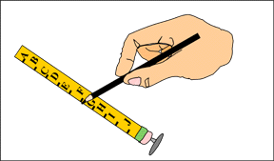 | 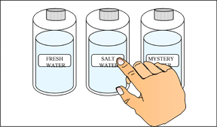

3) Prepare student workstation. | Student: 1) Pour water samples into cylinder. | 2) Mark depth of pencils.
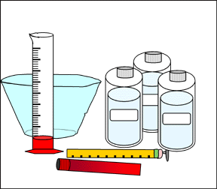 | 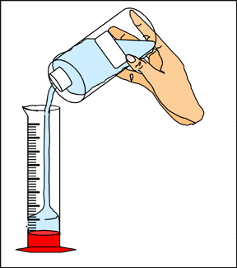 | 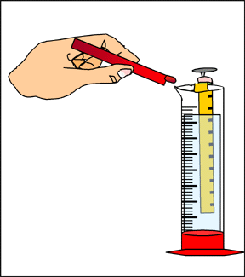

©1997-2005 SRI International, Center for Technology in Learning. All rights reserved. Terms of Use

