Half-Ball
Task with Student Directions
Contributed by: Kentucky Department of Education (KDE)
PERFORMANCE TASK STUDENT RESPONSE FORM
TASK: S2 - HALF-BALL
Grade 8
Student Name: _______________________________________________
School Name: _______________________________________________
School Code: _________

GENERAL INSTRUCTIONS:
Write your name, school name, and school code on the lines above. Do not open this packet until the directions tell you to do so. You will have a total of 45 minutes to complete this task. You may use up to 20 minutes to complete the group work.
Your group should have the following materials:
- one half-ball
- two meter sticks
- one racquetball
- calculators and pencils for each student
GROUP ACTIVITY:
Physical science plays a role in the way many things move. Among the principles of motion and energy are Newton's Laws of Motion and the Law of Conservation of Energy.
Newton's Laws of Motion
- If an object is at rest, it tends to stay at rest; if it is moving, it tends to keep moving at the same speed and in the same direction unless acted upon by an external force.
- Acceleration of a body is directly proportional to the net force acting on the body and inversely proportional to its mass.
- When one object exerts a force on a second object the second object exerts an equal and opposite force upon the first.
Law of Conservation of Energy
Energy is neither lost, destroyed, or created. The amount of energy in a system is constant as it transforms from one form to another.
Your task is to examine how a ball and half-ball behave and to relate as many of the laws described above to what happens to the balls.
Examine the illustration below. Notice how the half-ball is turned inside out with the curve pointing upward in the second picture.
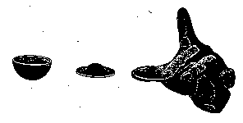

- Turn the ball inside out as shown in the illustration. Drop the ball, making sure that you drop it straight down, with the curved side pointing up. You will notice that the ball bounces back up to you. Practice this one or two times.
- Drop the half-ball three times from each of the following three heights: 50 cm, 100 cm, 200 cm. Each time, record on the table below how high the half-ball bounces.
HALF-BALL DATA 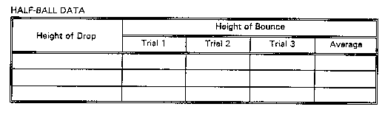
- Now drop the racquetball three times from the same three heights. Record the height of each bounce below.
RACQUETBALL DATA 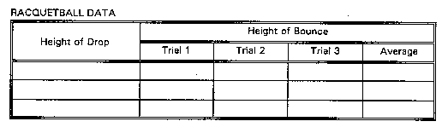
When you are finished with the work on this page, one member of the group should tell the facilitator that your group has finished. Then do the individual work. Remember that you must work alone on those pages. You may not discuss the questions or share information.
INDIVIDUAL ACTIVITY
- Produce an appropriate graph or graphs of the data your group collected.

- What conclusions can you draw concerning the half-ball?
__________________________________________________________________________
__________________________________________________________________________
__________________________________________________________________________
__________________________________________________________________________
__________________________________________________________________________
- What conclusion can you draw concerning the racquetball?
__________________________________________________________________________
__________________________________________________________________________
__________________________________________________________________________
__________________________________________________________________________
__________________________________________________________________________
- Refer to the data from your group's experiment. Describe what happened to the half-ball in terms of the laws stated on page 1. Be sure to consider each stage of each drop and the resulting bounces.
__________________________________________________________________________
__________________________________________________________________________
__________________________________________________________________________
__________________________________________________________________________
__________________________________________________________________________
- How did the bounces of the half-ball compare to the bounces of the racquetball? Explain why you think the bounces were similar or different.
__________________________________________________________________________
__________________________________________________________________________
__________________________________________________________________________
__________________________________________________________________________
__________________________________________________________________________
Kentucky Department of Education
Performance Events 1995-96

