Velocity
Task with Student Directions
Contributed by: Council of Chief State School Officers (CCSSO/SCASS)

TO THE STUDENT
Welcome to this experimental science exercise. We hope that you will find it interesting and worthwhile. Carefully read through these directions and the directions on the next page before you begin to work.
You may be part of a group for the first part of this exercise. Each group should carry out the experiment and collect the data together, but each student must record the data in his or her own booklet. Be sure to record the data exactly as you observe them. After the data have been collected, each student should answer the questions independently.
After you have finished your experiment and have recorded all of the data, you will be asked to answer some questions about the experiment and the data you recorded. Your answers must be written in this test booklet in the space provided. Make sure that you understand each question before you begin to write. At any time while you are writing your answers, you may look back to the directions for the experiment and the data you collected. Be sure that your answers are written as clearly and neatly as possible.
Before you turn the page, read the list of materials given below and check to make sure that your group has everything listed.
Materials
- self-propelled toy car
- meter stick
- masking tape
- stopwatch or watch with a second hand
- pen or pencil

AFTER YOU HAVE READ THE DIRECTIONS, TURN TO THE NEXT PAGE AND BEGIN.

Speeding in a School Zone
The speed limit sign in front of your school reads "25 miles per hour" (or 42 km/hour). Your local paper reports that cars frequently exceed the speed limit in the school zone. You want to design an experiment to examine the problem, but you need practice before you actually test cars driving by the school.
You will be working in a group of four students to collect data and share ideas. You will write the conclusions and answer questions on your own.
You are going to determine the average speed of cars as they travel along the floor. Average speed is equal to distance traveled divided by time (or speed = distance/time).
- Measure out a distance, in centimeters, and mark it on the floor with your masking tape. Determine how long, in seconds, it takes for the car to travel that distance. The same person should release the car and start the stopwatch. Each student should record both the time and the distance on his or her own data sheet.
- Repeat the process in Step 1 three times for each of the six different distances. Be sure that the longest distance is at least three times longer than the shortest distance.
- Calculate the average speed of the car in cm/sec for each of the three trials at the six distances. Show your work below the data sheet.
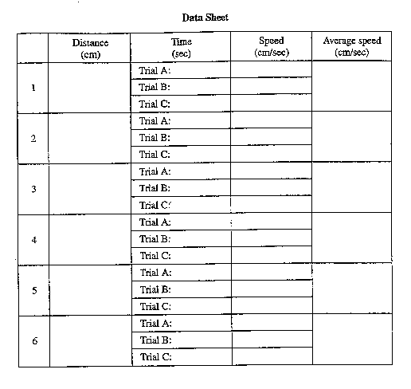
Questions
Please answer the following questions by yourself.
- Do you think your data is more accurate for long distances or for short distances? Why?
___________________________________________________________________
___________________________________________________________________
___________________________________________________________________
___________________________________________________________________
___________________________________________________________________
___________________________________________________________________
___________________________________________________________________
___________________________________________________________________
- Describe in detail an experiment to determine if cars that pass by your school are speeding.
___________________________________________________________________
___________________________________________________________________
___________________________________________________________________
___________________________________________________________________
___________________________________________________________________
___________________________________________________________________
___________________________________________________________________
___________________________________________________________________

