Balls and Ramp
Task with Student Directions
4th Grade Performance Task
Contributed by: New York State Education Department (NYSED)
NYS Alternative Assessment in Science Project (1996)

Task:
At this station, you will measure the distances different balls move a cup.

Materials:
- books
- plastic cup
- ruler
- golf ball
- practice golf ball
- rubber ball
- tape measure
- Ball X in a sealed plastic bag
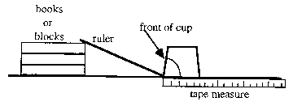

Directions:
- Make sure the equipment at your station is set up exactly as it looks in the diagram above. Make sure the cup is placed with the hole facing the ruler.
*** The balls must roll into the cup ***
*** Do not open bag with ball X ***
- Gently roll the golf ball from the top of the ruler.
- Measure, in centimeters, from the front of the cup, how far the golf ball moved the cup.
- Record your measurement on the data table.
- Repeat steps 2-4 for the practice golf ball and the rubber ball.
- Answer questions 2-4 on the answer sheet.

ANSWER SHEET
- Record your measurements on the data table below.
Object | Distance Cup Moved  (in centimeters)
Golf Ball
Practice Golf Ball
Rubber Ball

- Write a statement about the balls and the distances the cup moved. Base your statement on the data from the chart above.

- Write a statement explaining why the 3 balls produced different results.

- Examine ball X. Do not take the ball out of the plastic bag. You cannot test ball X, but if you could, predict how far the ball would move the cup.
_____________________ cm
Explain your prediction in the space below.

