Incline
Task with Student Directions
Contributed by: RAND
In this activity you will be working by yourself. Read each page carefully. Answer all the questions in the spaces provided.

SECTION I

PART I: Planning and Design
Please take the equipment out of the bag in front of you. You should have the following things:
EQUIPMENT:
- Inclined plane with ladder
- Truck with string and hook
- Bucket
- 4 Marbles (2 large, 2 small)
- 35 Metal washers
Set up the inclined plane and the ladder so that the inclined plane is at level 2. It should look like this:
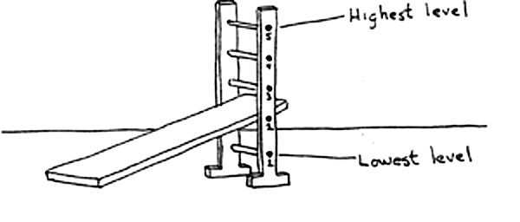

Put the truck on the inclined plane. Run the string underneath the rung of the ladder and over the pulley (spool) so that the hook hangs down over the inclined plane. Put the bucket on the hook. It should look like this:
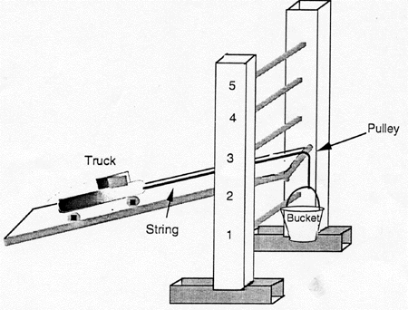
Practice pulling the truck up the inclined plane by putting washers in the bucket. The bucket should drop down to the table.
The number of washers in the bucket is a measure of the amount of force needed to pull the truck up the inclined plane.

MORE WASHERS = MORE FORCE
Now let's think of how we would solve some problems using the inclined plane.
Frank and Al are wondering if they need moreforce or lessforce to pull the truck up the inclined plane when they change the weight of the truck.
1. Suppose you add two large marbles to the truck. Will you have to put more washers, less washers, or the same number of washers in the bucket to pull the truck up the inclined plane?

2a. How does the amount of force you use to pull the truck up the inclined plane change when:
the truck is heavier?

2b. the truck is lighter?

Now let's think about a differentproblem.
Frank and Al have different ideas about how much force they would need to pull the truck up the inclined plane when the inclined plane is at different levels of the ladder.
Frank thinks that it takes more force to pull the truck up the inclined plane when the inclined plane is at a higher level than when it is at a lower level.
BUT
Al thinks that the level of the inclined plane does not matter. He thinks that it takes the same amount of force to pull the truck up the inclined plane at any level.
Can you think of an experiment you could do to test who is right? You can use the equipment in front of you to figure out how you could design an experiment.
3. BELOW, write down the steps you would follow to do your experiment. (If you need more space, you can write on the back of this page.)

PART II: Performance
Now let's see who is right.
REMEMBER:
Frank thinks that is takes more force to pull a truck up an inclined plane when the inclined plane is at a higher level than when it is at a lower level.
BUT
Al thinks that the level of the inclined plane does not matter. He thinks that it takes the same amount of force to pull the truck up the inclined plane at any level.
4. Use the equipment in front of you to test who is right, Frank or Al. Write down your results in the table below.
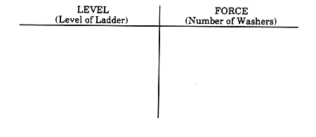

SECTION II
PART III: Analysis and Interpretation
Frank and Al did an experiment to test their ideas about the inclined plane. This is what they did:
- They set up the inclined plane at level 1 of the ladder. They set up the truck on the inclined plane.
- They added washers one by one to the bucket until the bucket fell down to the table. They wrote down the total number of washers it took to make the bucket drop down to the table.
- They repeated steps 1 and 2 for each level of the ladder. They alwaysreturned the bucket to the top before putting the washers in.
Frank and Al wrote down their results in the table below.
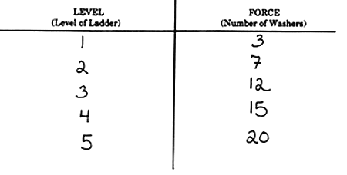
5. Use the information from the table to graph the findings from Frank's and Al's experiment.
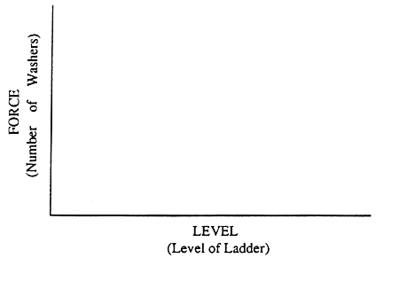
6. Look at Frank's and Al's results. How did the amount of force needed to pull the truck up the inclined plane change when the level increased?

Remember: Frank thought that it would take more force to pull the truck up the inclined plane when it is at a higher level than a lower level. Al thought that the amount of force needed to pull the truck would be the same at any level.
7. So who was right, Frank or Al?

8. How could you tell from the experiment who was right?

PART IV: Application
Your town has to decide where it will dump its garbage. The Hill dump is 10 miles away, but the garbage trucks have to go up a steep mountain to get there. The Level dump is also 10 miles away, but there are no hills to climb to get there.
The Hill dump charges $45 for each ton of garbage it receives. The Level dump charges $50 for each ton.
Also, your town has to pay for the gasoline the trucks use to take the garbage to the dump. (More gasoline = more force.) Which dump would cost the town more to use? Please circle your answer.
- Hill dump would cost more
- Level dump would cost more
- Both dumps would cost the same
- Cannot tell which dump would cost more
9. Use what you learned from Frank's and Al's experiment to explain the reason for your answer:

