Dichotomous Key
Task with Student Directions
8th Grade Performance Task
Contributed by: New York State Education Department (NYSED)
NYS Alternative Assessment in Science Project (1996)

Task:
With the millions of living organisms in the world, scientists need a method of identifying an unknown organism. To do this, scientists use a dichotomous key. At this station, you will be using a dichotomous key to identify unknown organisms.

Directions:
Use the dichotomous key below to identify any three (3) of the species of Triangulum in the accompanying Species Sheet. Record the choices made, and the resulting scientific name, on the answer sheet provided.
Dichotomous Key
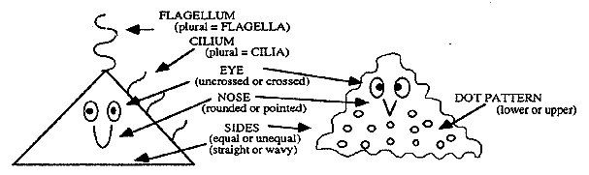
1. | A. | Sides are straight lines |  | Go to 2
 | B. | Sides are wavy lines |  | Go to 10
2. | A. | Has no eyes |  | Go to 3
 | B. | Has eyes |  | Go to 5
3. | A. | Has flagella for movement |  | Go to 4
 | B. | Has cilia for movement |  | Go to 7
4. | A. | The three sides are of equal length |  | Triangulum equalius
 | B. | The three sides are not of equal length |  | Go to 12
5. | A. | Has crossed eyes |  | Go to 6
 | B. | Eyes not crossed |  | Go to 9
6. | A. | Has a single flagellum for movement |  | Triangulum monoflagelleum
 | B. | Has two or more flagella for movement |  | Triangulum polyflagelleum
7. | A. | Total number of cilia for movement are odd |  | Triangulum oddcilius
 | B. | Total number of cilia fo rmovement are even |  | Go to 8
8. | A. | Has a pointed nose |  | Triangulum pointiatus
 | B. | Has a rounded nose |  | Triangulum roundiatus
9. | A. | Has two cilia on each side for movement |  | Triangulum biciliatus
 | B. | Has more than two cilia on each side |  | Triangulum Polycilius
10. | A. | Has crossed-eyes |  | Go to 11
 | B. | Eyes not crossed |  | Triangulum waveus (samplest correctus)
11. | A. | Lower half of the body has a dot pattern |  | Triangulum ventrodotteus
 | B. | Upper half of the body has a dot pattern |  | Triangulum dorsalidotteus
12. | A. | Has a pointed nose |  | Triangulum pointiflagelleum
 | B. | Has a rounded nose |  | Triangulum roundiflagelleum

Answer Sheet
Choose any three of the species of Triangulum from the Species Sheet and key them to their scientific names. Be sure to write in the numbers of the species that you are trying to identify. In the proper spaces below write in the number and letter (example #101) for each of the choices you made as you identified the species. When you are sure of the species identification, write in the scientific name in the space provided.
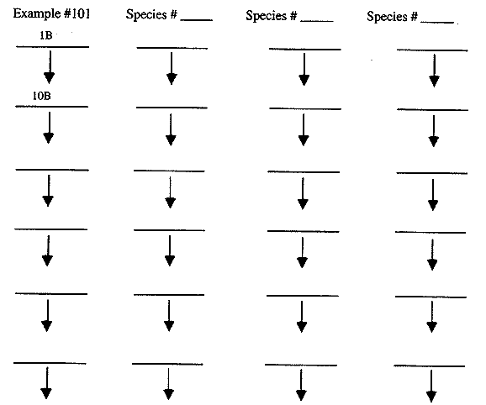

Scientific name of Example # | 101 | = | Samplest correctus
Scientific name of Species # ____________ = _______________________________
Scientific name for Species # ___________ = ________________________________
Scientific name for Species # ___________ = ________________________________

Species Sheet
